Quadkids Competition
Bank Holiday Monday 29th August 2016 from 0930

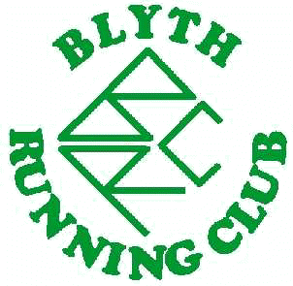

Blyth Running Club will be hosting this Quadkids event on the 29th August, with the aim of providing an exciting, fun and accessible event for young athletes. Each athlete will compete 4 events within their age groups, with results for individual events converted into points that will be totalled up at the end of the event. The emphasis is on fun and friendly competition, and there will be several UKA coaches on hand to assist and offer tips to the youngsters. All athletes will receive a certificate.

Events;
U9’s 50M Sprint, 400M, Standing Long Jump, Howler Throw
U11’s 75M Sprint, 600M, Long Jump, Howler Throw
U13’s 100M Sprint, 800M, Long Jump, Howler Throw

Entry Fee £3.00

Location: Churchill Playing Fields, Whitley Bay, NE26 3NS

Timetable of events:
TIME School Years 6&7 School Years 4&5 School year 3 and below
(Under 13 years*) (Under 11 years*) (Under 9 years*)
• all ages are as at 31st August 2016

09:30 REGISTRATION
10:00 Running Long Jump 600m 50m Sprint
10:25 100m Howler Throw Standing Long Jump
10:50 Howler Throw Running Long Jump 400m
11:15 800m 75m Sprint Howler Throw
11:45 4x100m Relays (mixed teams to be decided on day, relays will not count for points)
12:00 PRESENTATIONS

Pre-entry is recommended, using the entry form below. Please send to: Blyth Quadkids
c/o Daniel Njai, 5 De Merley Rd, Morpeth NE61 1HZ. Alternatively please email completed form to:
d-bradley-njai@hotmail.co.uk and pay on the day. Entries on day also accepted. Any queries please contact Daniel on above email address, or call 0772 563 4387

Entry form

Name …………………………………… Tel: …………………………………………..

Address…………………………………………… e-mail address…………………………………

…………………………………………………… Club(or unattached) …………………………. Post Code………………… D.O.B. ……………… Age Group ………… Boy Girl
Entry Fee £3.00 per competitor (cheques made payable to Blyth Running Club)
Location: Churchill Playing Fields, Whitley Bay, NE26 3NS
I AM MEDICALLY FIT TO RUN THIS EVENT AND TAKE PART AT MY OWN RISK. I UNDERSTAND THE ORGANISERS WILL IN NO WAY BE HELD RESPONSIBLE FOR ANY INJURY, ILLNESS OR LOSS OF PROPERTY AS A RESULT OF ME TAKING PART.
Signed:  Parent/Guardian if under 16 years | Date:
[N.B. By signing this form you consent to photographs being taken. Anyone wishing to take photographs must register their camera at registration.]
This form may be downloaded from the web at www.blythrunningclub.org.uk or photo copied

